Tracking flight activity of Potato Leafhopper (Hemiptera: Cicadellidae) with the Midwest Suction Trap Network

Doris M. Lagos-Kutz1, Nicholas Seiter2, Steven J. Clough1, Glen L. Hartman1, Robert E. Clark4, and Michael S. Crossley3,

1United States Department of Agriculture-Agricultural Research Service, Urbana, IL 61801

2Department of Crop Sciences, University of Illinois, Urbana, IL 61801

3Department of Entomology and Wildlife Ecology, University of Delaware, Newark, DE 19716

4EcoData Technology LLC, Plantsville, CT 06479

**Abstract**

Potato leafhopper (PLH), *Empoasca fabae*, Harris (Hemiptera: Cicadellidae), a native to North America, is an economic pest of a variety of crops including alfalfa, potato, snap beans, and soybean. PLH regularly colonizes host plants in northern latitudes each summer before migrating back to overwintering sites in the southern USA and Mexico. Since the early 2000s, the Midwest Suction Trap Network has monitored the magnitude and timing of activity of aerially dispersing aphids, but the potential of the network to monitor other taxa is only beginning to be explored. Here, we describe PLH activity as measured by the Midwest Suction Trap Network between 2018 and 2021 and examine how the magnitude and timing of PLH activity varied with geography, crop land cover, and time. We found that PLH aggregate activity-density generally increased between 2018-2021 and was higher at southern latitudes and at sites with more bean land cover. First detections occurred earlier in southern latitudes, while last detections occurred later in southern latitudes and over time between 2018-2021. PLH activity was thus longer in duration in southern latitudes and has continued to extend later into the year overall. Resolving uncertainty about how closely suction trap detections reflect the timing of immigration/emigration and population densities in local crop fields remains an important research priority before the potential of the Midwest Suction Trap Network for PLH monitoring can be realized. Still, the patterns that we observed suggest that PLH could potentially increase in economic importance as more insects are dispersing over larger portions of the growing season in the agriculturally productive US Midwest.

KEY WORDS: *Empoasca fabae*, potato leafhopper, suction traps, migration

**Introduction**

Potato leafhopper (PLH), *Empoasca fabae*, Harris (Hemiptera: Cicadellidae) is a highly polyphagous insect with more than 200 plant species listed as hosts including weeds, forest plants (Poos and Wheeler 1943, Lamp et al. 1984, 1994) and various crops of economic importance such as alfalfa (*Medicago sativa* L.), potato (*Solanum tuberosum* L.), snap beans (*Phaseolus vulgaris* L.), and soybean (*Glycine max* L.) (Chasen et al. 2014). PLH adults and nymphs pierce leaves and stems to suck plant juices, with extensive feeding causing plant stunting and yellowing damage known as hopper-burn. Hopper-burn in alfalfa has been associated with delayed growth as well as reduced stand longevity, forage quality, and yield (Schillinger et al. 1964, Smith and Ellis 1983, Hutchins and Pedigo 1989). In soybean, heavy PLH infestations can lead to plant stunting, smaller seed size, and yield loss (Yeargan et al. 1994). The geographic range of the PLH extends from the eastern seaboard of the United States westward to the Rocky Mountains (Delong 1931) and northward into the bordering Canadian provinces (Fick et al. 2003).

The migration pattern of PLH has been of great interest since an early report from Wisconsin showed great population increases in spring attributed to a depression over the Great Plains and an anticyclone over the Atlantic, drawing warm and wet southerly air from the Gulf of Mexico (Pienkowski and Medler 1964). These conditions frequently occur every spring and were shown to favor PLH females to make the flight from the Gulf Coast to the Great Lakes region and survive without food or water for 80 hours in a humid atmosphere (Decker and Cunningham 1968). Consequently, it was shown that PLH populations decline during the summer in Louisiana while reaching their maxima in the northern states, followed by a late summer decline, and disappearing from northern latitudes altogether by the first autumn frost (Taylor and Shields 2018). Furthermore, PLH’s overwintering behavior on southern pine and its annual circular migration pattern was corroborated by the lack of genetic variation between widely separated populations of PLH, both spatially and temporally (Taylor et al. 1993, 1995). Most studies agree that arrival times and peaks in northern states occur between April and June (Parr and Pass 1989, Carlson et al. 1992, Emmen 2004, Erlandson et al. 2016). But no correlation was found between the timing of PLH arrival and expert opinion-based measures damage severity at a state level among states over time (Maredia et al. 1998, Baker et al. 2015).

<Paragraph introducing the Midwest Suction Trap Network, ending with the sentiment that the network could be put to good use tracking more than ‘just’ aphids. It would be good to include a sentence affirming how trap captures can be related to local conditions – to assuage skeptics.>

Here, we documented PLH captures in the Midwest Suction Trap Network between 2018 and 2021, representing the most geographically widespread, systematic, empirical sampling effort of PLH to date. We examined the utility of PLH suction trap captures to monitor PLH activity by summarizing the magnitude and timing of PLH activity for each location and year, and used generalize linear models to examine associations with geography, crop land cover, and time.

**Materials and methods**

*Potato leafhopper data*

Suction trap samples were collected weekly from 18 May to 19 October in 2018, 17 May to 18 October in 2019, 22 May to 23 October in 2020 and 21 May to 22 October in 2021. Details about location information can be found in Lagos-Kutz et al. (2020), except for Concord, Nebraska (GPS: 42.386, -96.958; collector: Nicole Luhr) which was added to the network in 2019. PLH from the trap samples were identified and counted by DL-K. A selection of specimens was deposited at the INHS-Insect Collection by using the following voucher numbers: 1011441-1011460.

For statistical analyses, we calculated the PLH aggregate activity-density as the sum of PLH detected at a given suction trap in a given year. We also summarized two phenology metrics for each suction trap and year: the day of year when PLH were first detected, and the day of year when PLH were last detected. All models only included suction trap locations in which PLH were detected before August 1.

*Land cover data*

Land cover data were obtained from the United States Department of Agriculture – National Statistics Service Cropland Data Layer (USDA-NASS 2021). To determine the effects of nearby crop cover on PLH, landscape-scale data were retrieved on alfalfa, beans, and potato near each suction trap site. With these landscape-scale data, proportions alfalfa (code 36), beans (codes 5, 26, 42, 239, 240, 241, and 254), and potato (code 43) were calculated as the number of 30x30 m pixels classified as alfalfa, beans, or potato, respectively, divided by the total number of pixels within a 1 km radius circle around the suction trap site. We used functions available in the ‘raster’, ‘rgdal’, and ‘rgeos’ R packages to curate all spatial data (Bivand and Rundel 2021, Bivand et al. 2021, Hijmans 2022). Environmental covariates were visualized using the R package ‘tmap’ (Tennekes 2018).

*Statistical analysis*

We modeled aggregate PLH activity-density, day of first detection, and day of last detection using generalized linear models (GLMs) that included the same set of predictor variables. These models included the predictor variables of year, number of weeks sampled (ranged from 16 to 23), latitude, proportion alfalfa, proportion beans, and proportion potato. The aggregate PLH activity-density model included a negative binomial error structure (family=‘nbinom2’), while both phenology models included a Gaussian error structure. Generalized linear models were implemented with the *glmmTMB* function available in the ‘glmmTMB’ R package (Brooks et al. 2017). In our GLMs, we employed sequential replacement approach using Akaike Information Criterion (AIC) to reduce the number of fixed effects (predictor variables) and increase statistical power by establishing the most parsimonious models. To be consistent in our model selection, after fitting global models, we used the *stepAIC* function in the ‘MASS’ R package (Venables & Ripley 2002). Where two or more predictor variables were retained in model using the stepAIC appraoch, multicollinearity among covariates was assessed using the *check_collinearity* function in the ‘performance’ R package (Ludecke et. al 2020), and variance inflation factors were all < 2. Spatial autocorrelation in residuals was checked using the *testSpatialAutocorrelation* function in the ‘DHARMa’ R package (Hartig 2020), and no evidence of spatial autocorrelation was found.For data visualization and effect size estimation, parameter estimates visualized using the ‘sjPlot’ R package (Ludecke 2021).

**Results**

In 2018, Urbana-Champaign II, IL had peaks of activity-density on 1 June (47 individuals), 6 July (27), 13 July (16) and 20 July (17) (Figs. 1 & 2). In 2019, Freeport, IL had the highest peaks on 5 July (13) and on 2 August (23), and in Kanawha, IA the peak was on 7 June (27) (Figs. 1 & 3). In 2020, Urbana-Champaign II, IL had peaks on 13 June (36), 10 Jul (10) and 31 July (13), Lafayette, IN had peaks on 29 May (10) and 19 June (17), and Kanawha, IA had multiple peaks of activity-density on 3 July (17), 7 August (11) and 21 August (14) (Figs. 1 & 4). In 2021, Orr, IL had a peak on 18 June (29), Columbia City, IN had a single peak on 11 June (13), and in Lafayette, IN on 1 October (11), Kanawha, IA had two peaks on 11 June (14) and 23 July (38), and in Hancock, WI on 20 August (35) (Figs. 1 & 5). The suction traps not mentioned above from Illinois, Indiana, Iowa, Kansas, Louisiana, Michigan Minnesota, Missouri, Nebraska and Wisconsin never had counts exceeding 10.

PLH aggregate activity-density generally increased between 2018-2021 (Table 1, Fig. 6a). PLH aggregate activity-density was generally higher at more southern latitudes (Table 1, Fig. 6b) and in landscapes that had more bean land cover (Table 1, Fig. 6c).

First detections occurred as early as May 18, but sometimes occurred in mid-June or July (and in rare instances PLH were not detected until September) (Figs. 2-5). Last detections occurred as late as October 23, but sometimes occurred in mid-August or September (and in rare instances PLH were not detected after June) (Figs. 2-5). PLH first detections were only found to be associated with latitude, with first detections generally occurring earlier in more southern latitudes (Table 1, Fig. 6d). PLH last detections generally occurred earlier at more northern latitudes (Fig. 6e) and occurred later between 2018-2021 (Fig. 6f). The contrasting effects of latitude on first and last detections reflect how PLH is typically active earlier and for a longer duration in more southern latitudes. Furthermore, the shifts in timing of last detections over time, combined with the lack of temporal trend in first detections suggests that PLH activity has generally been extending later into the year from 2018-2021 (Fig. 7).

**Discussion**

Reliable monitoring PLH may assit pest management for multiple states across the US Midwest where this pest is abundant (Gyrisco et al. 1978, Armbrust and Lamp 1989, Chasen et al. 2014). PLH migrates northward each growing season after overwintering on southern pine in Louisiana (Taylor et al. 1993, 1995). In the midwestern US, PLH populations move in one or more major migration events during the spring season (Medler 1957; Pienkowski & Medler 1964; Taylor & Reling 1986). Early detection in the northern states occurs in March, with peaks recorded between May and June (Parr and Pass 1989, Carlson et al. 1991, Maredia et al. 1998). The suction trap networks observations matches these prior accounts, but for few locations in Illinois (Freeport, Orr and Urbana-Champaign II), Indiana (Columbia City and Lafayette), Iowa (Kanawha) and Wisconsin (Hancock), where the peaks of activity varied between years and specific locations per state. In this survey, the migration of PLH to the south was not observed because of lower catches in late summer and fall for most of suction trap locations. Movement of PLH southward may be restricted by pest management practices in critical hosts like alfalfa.Prior work demonsrates cutting alfalfa to a 2-to 5-cm stubble height resulted in >95% in nymphal and egg mortality (Simonet and Pienkowski 1979). Further practices may also assist in reducing populations to prevent this southward migration, including grower adoption of no-glabrous resistant alfalfa and soybean varieties in addition to systemic neonicotinoid insecticides to control Colorado potato beetle, *Leptinotarsa decemlineata* Say (Hammond and Jeffers 1990, Danielson et al. 1991, Huseth et al. 2014, Mccormick et al. 2014).

In addition, our study showed that there was a significant negative interaction between “spring temperature” and “spring precipitation”. Specifically, predicted spring PLH counts increased with increasing spring temperature only when spring precipitation was low. This corroborates the effect of temperature on PLH development, which has widely been studied (Simonet and Pienkowski 1980, Hogg 1985, Kieckhefer and Medler 1964), but not the effect on flying activity. In 1986, Taylor & Reling used aircraft mounted nets to monitor the density of PLH. They found that the major flight thresholds of PLH are temperature and light dependent, and so their flight is most frequent during the crepuscular periods and major peak in the evening. PLH’s migration flight is in response to light intensity and/or wavelength provided that a minimum air temperature exceeds 15 º C (Taylor 1974). Similarly, Baker et al. (2015) found a significant and positive effect on the severity of infestation of PLH when temperature rises. They analyzed data collected from multiple states between 1951 and 2012 and concluded that the arrival time of PLH has advanced by 10 days over the last 62 years.

Lastly, out of all the effects of crop proportions (alfalfa, potato, and beans) analyzed in this study were not significant, and this might be because the strong climatic effects on migration movement and as well as the insect pest management applied across the US Midwest. We recommend continuing gathering data due to climate changes and add field sampling close to the suction traps to correlate the abundance of PLH in the field and suction traps and potentially make conclusions to be implemented in the integrated pest management of this insect pest.

**Acknowledgements**

We thank the North Central Soybean Research Program, United Soybean Board and United States Department of Agriculture-Agricultural Research Service for financial support of the suction trap network. Special thanks to the collaborators in the Midwest for checking and maintaining traps, and University of Illinois at Urbana-Champaign undergrad assistants Benjamin Daniels, Madelaine Burke and Timothy Jun.

**References cited**

Armbrust, E. J. and W. O. Lamp. 1989. History and perspectives of potato leafhopper (Homoptera: Cicadellidae) research. Csc. Publ. 72, Entomol. Soc. Am., Lanham, MD.

Baker, M. B., P. D. Venugopal, and W. O. Lamp. 2015. Climate change and phenology: *Empoasca fabae* (Hemiptera: Cicadellidae) migration and severity of impact. PloS one 10: e0124915, 1-12.

Barton 2020

Bentz, J., and A. M. Townsend. 1999. Feeding injury, oviposition, and nymphal survivorship of the potato leafhopper on red maple and freeman maple clones. Environ. Entomol. 28:456-460.

Bivand et al. 2020

Bivand and Rundel 2020

Brooks et al. 2017

Busler, B. 2022. Wisconsin Ag News – 2019 Crop Production. USDA- National Agriculture Statistics Services. Available at <https://www.nass.usda.gov/Statistics_by_State/Wisconsin/Publications/Crops/2020/WI-Crop-Production-Annual-01-20.pdf>

Carlson, J. D., M.E. Whalon, D.A. Landis, and S.H, Gage. 1992. Springtime weather patterns coincident with long distance migration of potato leafhopper into Michigan. Agric. For. Meteorol. 59:183–206.

Chasen, E.M., C. Dietrich, E. A. Backus, and E. M. Cullen. 2014. Potato Leafhopper (Hemiptera: Cicadellidae) Ecology and Integrated Pest Management Focused on Alfalfa. J. Integ. Pest Mngmt. 5(1): 1–8.

Cherry, R. H., K. A. Whalon, and W. G. Ruesink. 1977. Emergence trap and sweep net sampling for adults of the potato leafhopper from alfalfa. J. Econ. Entomol. 70: 279–282.

Cuperus, G. W., C. G. Watrin, and E. B. Radcliffe. 1983. Influence of postharvest alfalfa stubble on potato leafhopper, *Empoasca fabae* (Harris) (Homoptera: Cicadellidae). J. Kans. Entomol. Soc. 59: 246–252.

Danielson, S. D., G. R. Manglitz, and E. L. Sorensen. 1991. A Field Study of Potato Leafhopper (Homoptera: Cicadellidae) Abundance and Damage on Alfalfa Cultivars and Perennial Glandular-Haired Medicago Strains. J. Kans. Entomol. Soc. 64: 152–155.

Decker, G. C., and H.B. Cunningham. 1968. Winter survival and overwintering area of the potato leafhopper. J. Econ. Entomol. 61: 154–161.

Delong, D. M. 1931. Distribution of the potato leafhopper (*Empoasca fabae* Harris) and its close relatives of *Empoasca*. J. Econ. Entomol. 24: 475– 479.

DeGooyer, T. A. 1997. Population dynamics and management of potato leafhopper and other insect pests in forage systems. Ph.D. Thesis. Iowa State University, IA.

Dysart, R. J. 1962. Local movement of potato leafhoppers in alfalfa. Proc. North Central Branch Entomol. Soc. Am. 17: 100–101.

Emmen, D. A., S. J. Fleischer, and A. Hower. 2004. Temporal and spatial dynamics of *Empoasca fabae* (Harris) (Homoptera: Cicadellidae) in alfalfa. Environ. Entomol. 33: 890–899.

Fick, G. W., W. O. Lamp, and M. Collins. 2003. Integrated pest management in forages, pp. 295–314. In R. F. Barnes, C. J. Nelson, M. Collins, and K. J. Moore (Eds.), Forages: an introduction to grassland agriculture. Iowa State Press, Ames, IA.

Fleischer, S. J. and W. A. Allen. 1982. Field counting efficiency of sweep-net samples of adult potato leafhoppers (Homoptera: Cicadellidae) in alfalfa. J. Econ. Entomol. 75: 837–840.

Gyrisco, G. G., D. Landman, A. C. York, B. J. Irwin, and E. J. Armbrust. 1978. Literature of arthropods associated with alfalfa. IV. Bibliography of potato leafhopper (*Empoasca fabae* (Harris)) (Homoptera; Cicadellidae). 111. Agr. Exp. Pub.

Hammond, R. B., and D. L. Jeffers. 1990. Potato leafhopper (Homoptera: Cicadellidae) populations on soybean relay intercropped into winter. Environ. Entomol. 19: 1810-1819.

Hartig, F. 2020. DHARMa: Residual Diagnostics for Hierarchical (Multi-Level / Mixed) Regression Models.

Hijmans 2020

Hogg, D. B. 1985. Potato Leafhopper (Homoptera: Cicadellidae) immature development., life tables., and population dynamics under fluctuating temperature regimes. Environ. EntomoL. 14: 349–355.

Huseth, A. S, R. L. Groves, S. A. Chapman, A. Alyokhin, T. P. Kuhar, I. V. Macrae. 2014. Managing colorado potato beetle insecticide resistance: new tools and strategies for the next decade of pest control in potato. J. Integr. Pest Manag. 5: A1–A8.

Hutchins, S. H. and Pedigo, L. P. 1989. Potato leafhopper-induced injury on growth and development of alfalfa. Crop. Sci. 29: 1005–1011.

Kieckhefer, R. W., and J. T. Medler. 1964. Some environmental factors influencing oviposition by the potato leafhopper, *Empoasca fabae*. J. Econ. Entomol. 57: 482–484.

Lamp, W. O., M. J. Morris, and E. J. Armbrust. 1984. Suitability of common weed species as host plants for the potato leafhopper, *Empoasca fabae*. Entomol. Exp. Appl. 36: 125-131.

Lamp, W. O., G. R. Nielsen, and S. D. Danielson. 1994. Patterns among Host Plants of Potato Leafhopper, Empoasca fabae (Homoptera: Cicadellidae). J. Kans. Entomol. Soc. 67: 354–368.

Lagos-Kutz, D.M., D. Voegtlin, D., Onstad, D., Hogg, D., Ragsdale, K. Tilmon, E. Hodgson, C., Difonzo, R., Groves, C., Krupke, J., Laforest, N. J. Seiter, E., Duerr, B., Bradford, and G. L. Hartman. 2020. The soybean aphid suction trap network: Sampling the aerobiological “soup". American Entomologist 66:48–55.

Lawson, F.R., J.C. Chamberlin, and G.T. York. 1951. Dissemination of the beet leafhopper in California. USDA Tech. Bull. 1030: 1–59.

Lofthus, D. 2022. Minnesota Ag News – 2019 Crop Production. USDA- National Agriculture Statistics Services. Available at <https://www.nass.usda.gov/Statistics_by_State/Minnesota/Publications/Crops_Press_Releases/2020/MN-Crop-Production-Annual-01-20.pdf>

Lüdecke, D., D. Makowski, P. Waggoner, and I. Patil. 2020. performance: Assessment of Regression Models Performance. CRAN.

Luna, J. M., S. J. Fleischer, and W. A. Allen. 1983. Development and validation of sequential sampling plans for potato Leafhopper (Homoptera: Cicadellidae) in Alfalfa. Environ. Entomol. 2: 1690–1694.

Maredia, K. M., M. E. Whalon, S. H. Gage, and M. J. Kaeb. 1998. Observations of first occurrence and severity of potato leafhopper, *Empoasca Fabae* (Harris), (Homoptera: Cicadellidae) in the North Central and Eastern United States. Gt. Lakes Entomol. 31: 73–84.

Mccormick et al. 2014

Nakagawa, S., P. C. D. Johnson, and H. Schielzeth. 2017. The coefficient of determination R2 and intra-class correlation coefficient from generalized linear mixed-effects models revisited and expanded. Journal of the Royal Society Interface 14.

NASS-USDA. 2021. Michigan Agricultural Statistics 2018-2019. Available at <https://www.nass.usda.gov/Statistics_by_State/Michigan/Publications/Annual_Statistical_Bulletin/stats19/agstat2019.pdf>

Ogunlana, M., and L. Pedigo. 1974. Pest status of the potato leafhopper. J. Econ. Entomol. 201–202.

Parr, J. C., and B. C. Pass. 1989. Seasonal Occurrence of Adult Potato Leafhopper, *Empoasca fabae* (Homoptera: Cicadellidae), on Alfalfa in Kentucky. J. Kans. Entomol. Soc. 62: 593–596.

Pienkowski, R. L., and J. T. Medler. 1962. Effects of alfalfa cuttings on the potato leafhopper, *Empoasca fabae*. J. Econ. Entomol. 55: 973–978.

Pienkowski, R. L. and J. T. Medler. 1966. Potato leafhopper trapping studies to determine local flight activity. J. Econ. Entomol. 59: 837–843.

Poos, F. W. & Wheeler, Nancy H., 1943. Studies of host plants of the leafhoppers of the genus *Empoasca*. Technical bulletins 169439, United States Department of Agriculture, Economic Research Service.

Poston, F. L., and L. P. Pedigo. 1975. Migration of plant bugs and the potato leafhopper in a soybean-alfalfa complex. Environ. Entomol. 4: 8 –10.

Reling, D. 1983. Aerial sampling to determine some factors affecting flight of the potato leafhopper (Homoptera: Cicadellidae). M.S. Thesis. The Pennsylvania State University, State College, PA.

Schroeder, P. C., R. L. Brandenburg, and C. J. Nelson. Interaction between moisture stress and potato leafhopper (Homoptera: Cicadellidae) damage in alfalfa. J. Econ. Entomol. 81: 927–933.

Shields, E.J., and A. Testa. 1999. Fall migratory flight initiation of the potato leafhopper*, Empoasca fabae* (Harris) (Homoptera: Cicadellidae): observations in the lower atmosphere using remote piloted vehicles. Agric. For. Meteorol. 97: 317–330.

Simonet, D. E. and R. L. Pienkowski. 1979. Impact of alfalfa harvest on potato leafhopper populations with emphasis on nymphal survival. J. Econ. Entomol. 72: 428–431

Simonet, D. E., and R. L. Pienkowski. 1980. Temperature effect on development and morphometrics of the potato leafhopper. Environ. Entomol. 9: 798–800.

Smith, S. M. and C. R. Ellis. 1983. Economic importance of insects on regrowth of established alfalfa fields in Ontario. Can. Emomol. 115: 859–864.

Sulc, R. M., J. S. Mccormick, R. B. Hammond, D. J. Miller. 2014. Population responses of potato leafhopper (Hemiptera: Cicadellidae) to insecticide in glandular-haired and non-glandular-haired alfalfa cultivars. J. Econ. Entomol. 107: 2077–2087.

Taylor, L. R. 1974. Insect migration, flight periodicity and the boundary layer. J. Anim. Ecol. 43: 225–238.

Taylor, R.A.J., and D. Reling. 1986. Preferred wind direction of long-distance leafhopper (Empoasca fabae) migrants and its relevance to the return migration of small insects. J. Anim. Ecol. 55: 1103–1114.

Taylor et al. 1995 Empoasca fabae (Homoptera: Cicadellidae) Identification and Population Studies with Allozyme Electrophoresis?

Teulon, D.A.J., and I.A.W. Scott. 2006. The use of suction traps for detection of unwanted invasive insects and other invertebrates. N. Z. Plant Prot. 59: 125–131.

van Emden and Way 1973

Weiser Erlandson, L.A., J.J. Obrycki, and M.E. Rice. 2016. Early Spring Occurrence of *Empoasca* spp. (Hemiptera: Cicadellidae) in and Adjacent to Alfalfa Fields in Iowa. J. Entomol. Sci. 51(3): 238–249.

Yeargan, K., S. Braman, and W. Barney. 1994. Effects of potato leafhoppers on soybean plant growth and yield. J. Kans. Entomol. Soc. 67: 29–36.

**Tables**

**Table 1.** Model summary table of most parsimoniousgeneralized linear models. Parameters in accepted models included the predictor variables Year, Latitude, and Proportional cover of bean and alfalfa. Estimate indicates relative effect size and direction alongside standard error. Z-value were used as critical values to calculate statistical significance.

|  |  |  |  |  |  |
| --- | --- | --- | --- | --- | --- |
| Response variable | Parameter | Estimate | Standard error | Z-value | P-value |
| Total PLH |  |  |  |  |  |
|  | Year | 0.24 | 0.11 | 2.17 | **0.030** |
|  | Latitude | -0.23 | 0.06 | -3.57 | **<0.001** |
|  | Prop. beans | 2.63 | 0.84 | 3.15 | **0.002** |
| First detection | |  |  |  |  |
|  | Latitude | 3.46 | 0.98 | 3.54 | **<0.001** |
| Last detection | |  |  |  |  |
|  | Year | 7.06 | 2.35 | 3.00 | **0.003** |
|  | Latitude | -2.81 | 1.30 | -2.16 | **0.031** |
|  | Prop. alfalfa | 18.70 | 38.21 | 0.49 | 0.625 |
|  | Prop. beans | -7.67 | 16.51 | -0.47 | 0.642 |

**Figures**

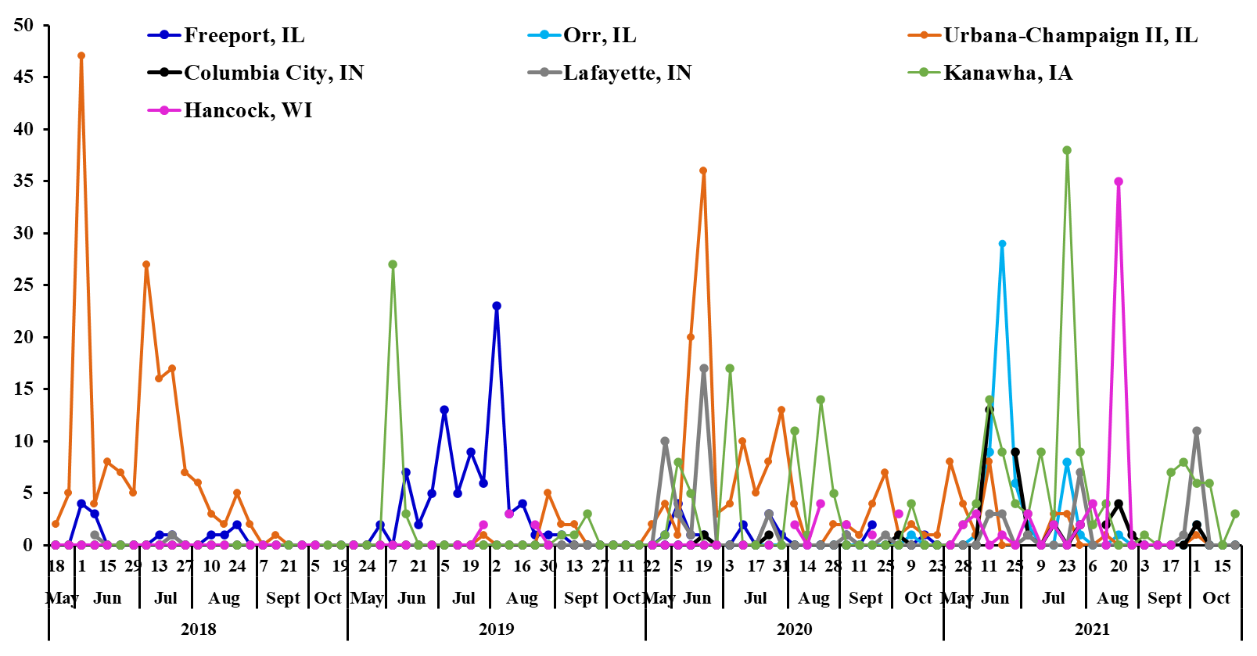

**Figure 1.** Seasonal population dynamics of the potato leafhoppers, *Empoasca fabae*, collected in 2018, 2019, 2020 and 2021 from selected sites and states represented by the Midwest Suction Trap Network.

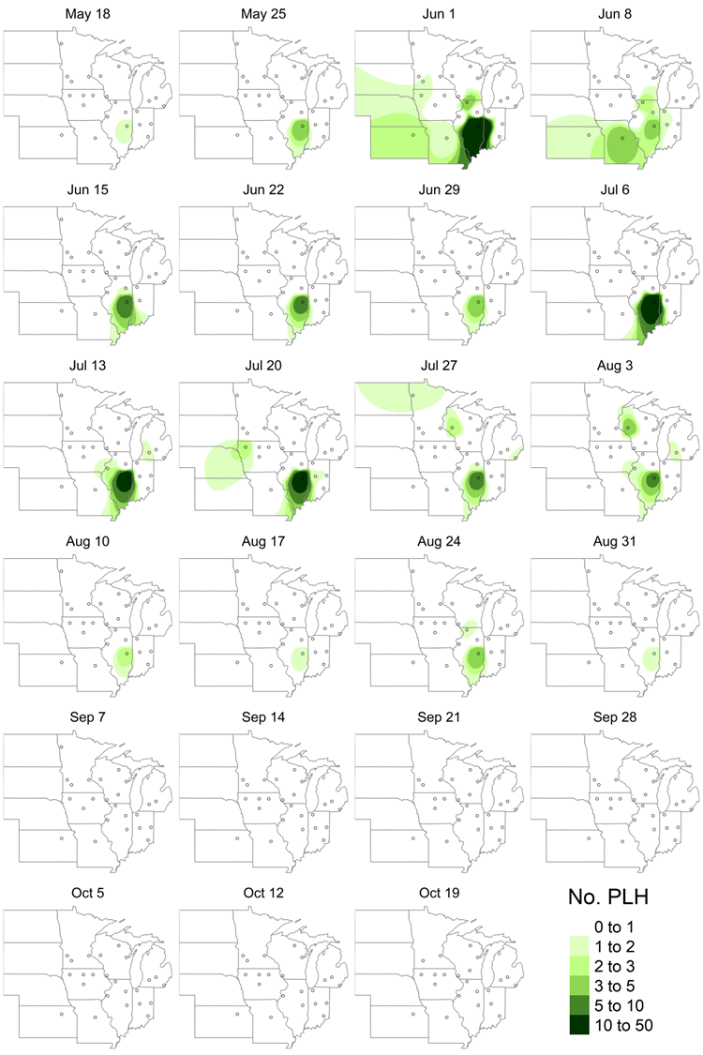

**Figure 2.** Potato leafhopper detections reported by the Midwest Suction Trap Network in 2018. Maps depict inverse distance weighted interpolations.

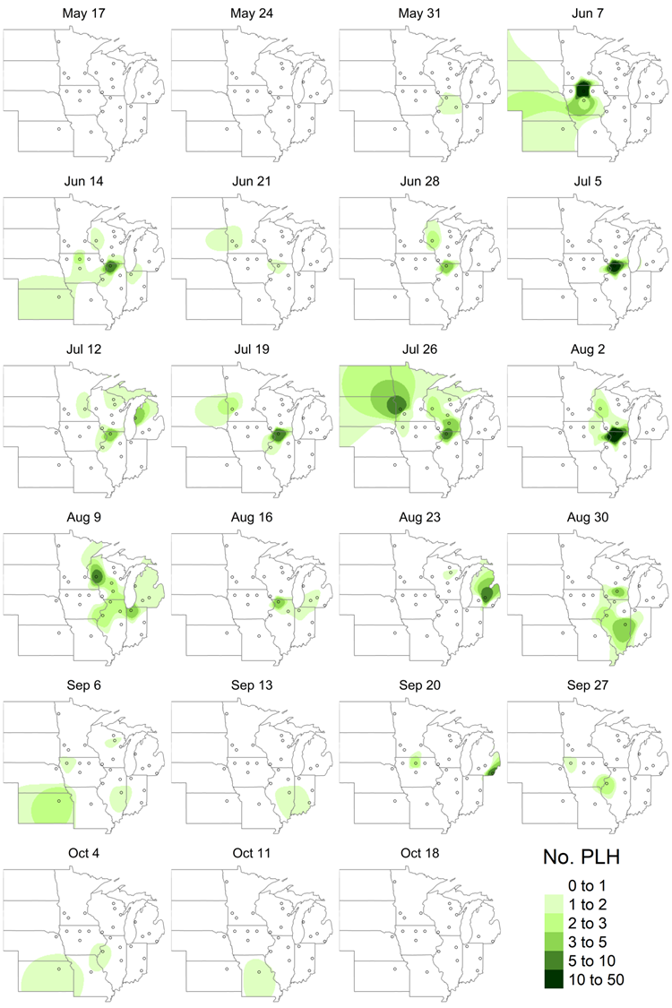

**Figure 3.** Potato leafhopper detections reported by the Midwest Suction Trap Network in 2019. Maps depict inverse distance weighted interpolations.

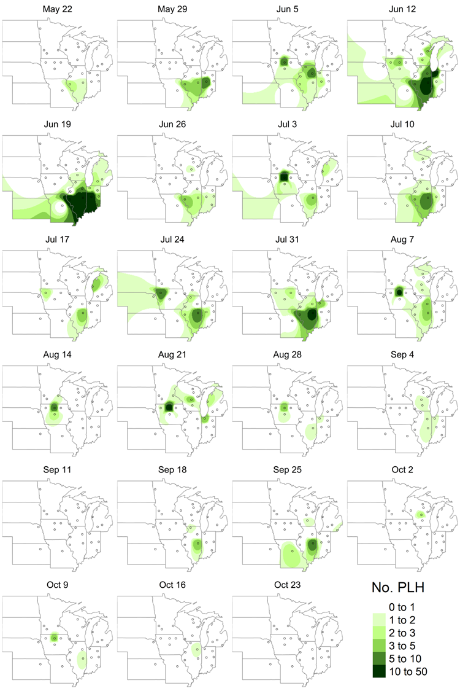

**Figure 4.** Potato leafhopper detections reported by the Midwest Suction Trap Network in 2020. Maps depict inverse distance weighted interpolations.

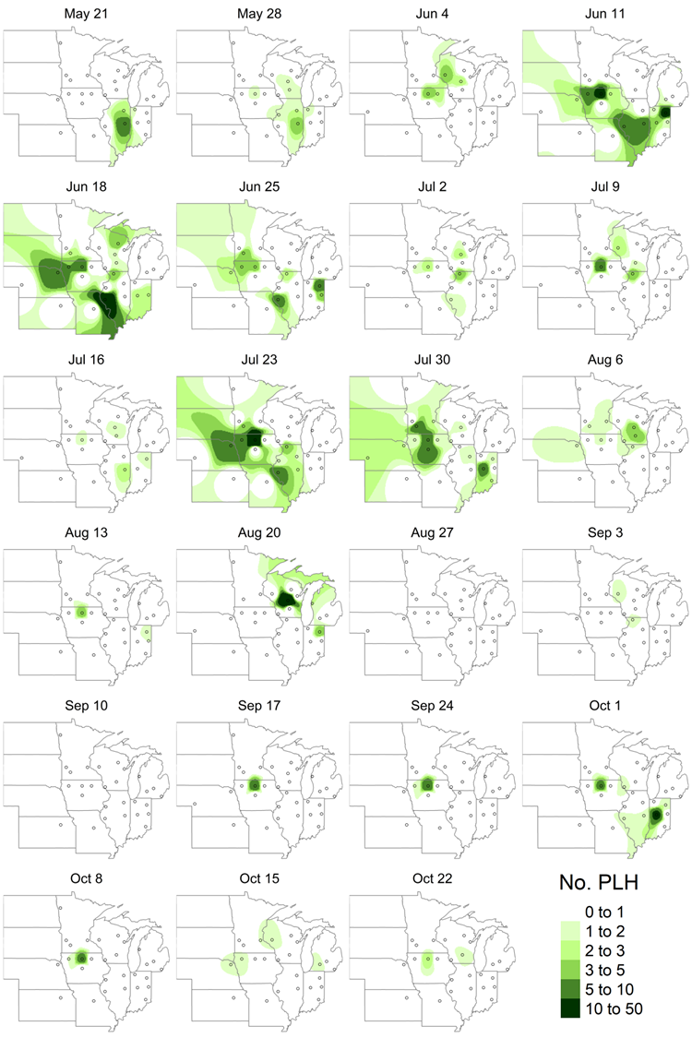

**Figure 5.** Potato leafhopper detections reported by the Midwest Suction Trap Network in 2021. Maps depict inverse distance weighted interpolations.

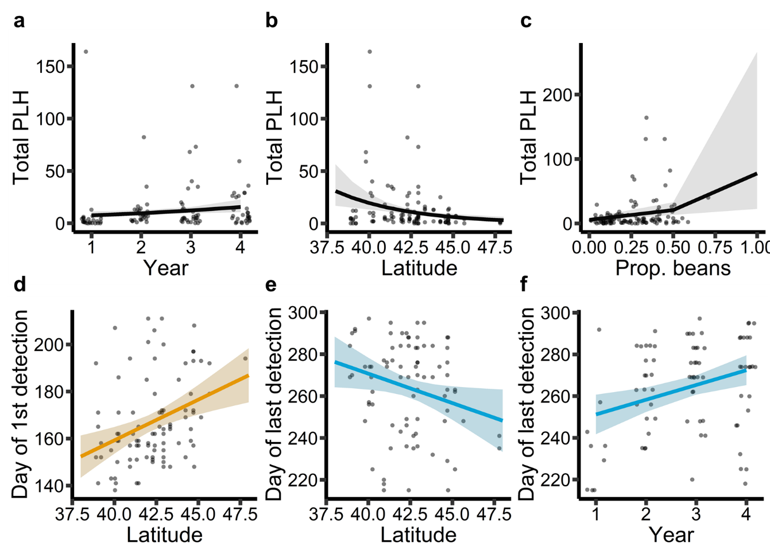

**Figure 6.** Significant covariate effects estimated by generalized linear models. (a-c)Effects of year, latitude, and proportion bean land cover in surrounding landscape on total potato leafhopper counts (aggregate activity-density). (d) Effect of latitude on day of first potato leafhopper detection. (e-f) Effects of latitude and year on day of last potato leafhopper detection.

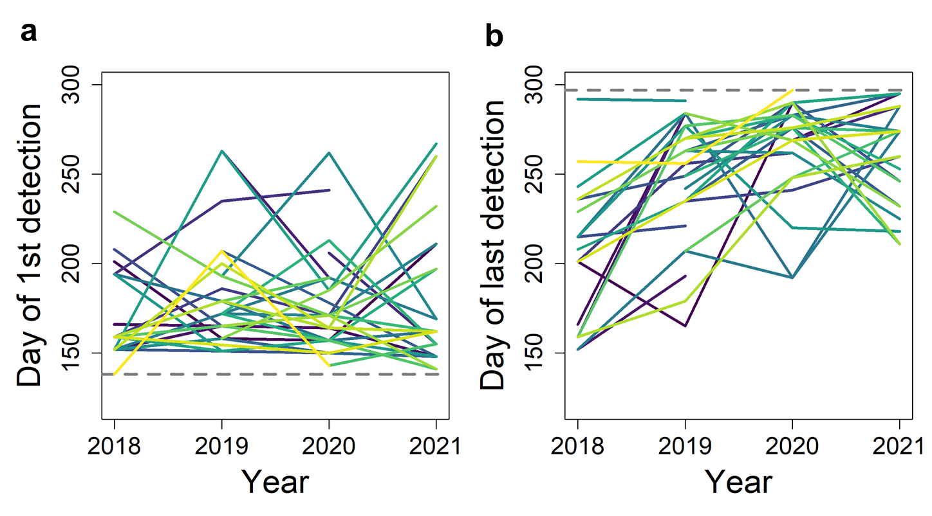

**Figure 7.** (a)Day of year when potato leafhopper first detections occurred. Each solid line corresponds to a suction trap site. The dashed line indicates the earliest day when sampling began. (b) Day of year when potato leafhopper last detections occurred. Each solid line corresponds to a suction trap site. The dashed line indicates the latest date when sampling ended.